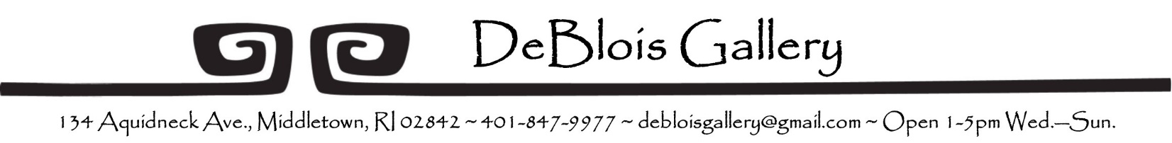

WORK FOR REVIEW FORM
DATE:
NAME:
ADDRESS:
PHONE:
E-MAIL:
WEBSITE:
MEDIA (oil, monotype, stoneware, mixed, etc. Note: giclee not accepted):

SHORT DESCRIPTION OF WORK (Subject matter and style):

RANGE OF SIZES AND PRICES (Gallery commission is 35%):

PREFERRED SHOWING MONTH (if any):

Thank you for considering DeBlois Gallery for your work. The gallery reviews work submitted for future shows at its monthly meetings. Please call or e-mail the gallery for the date of the next meeting. (401-847-9977) or debloisgallery@gmail.com
Email this form and a resume to debloisgallery.com, with the subject line Att’n Show Committee. Please attach several representative digital images or links for review. Due to the gallery’s very limited storage space, we are unable to accept actual work at the gallery.
Be sure the work presented for review is representative of the work you would like to show, or that there is a statement about differences expected. It is important that work reviewed is consistent with the work that will be shown with regard to price, size and style.
Your work will be reviewed at the next members’ meeting following submission. You will receive a letter with the gallery’s decision after your work has been reviewed. DeBlois expects that you will agree that the pieces for your DeBlois show have not been exhibited in the local area during six months prior to your exhibition with us.
.
DeBlois Gallery’s General Show Guidelines
The following are responsibilities of guest artists and the gallery members during the preparation, opening and run of a show. Should your work be selected, additional information will be provided by the Show Committee and the Member/Coordinator assigned to your exhibition.

ABOUT SHOWS:
Most exhibitions are 2- to 4-person shows. Gallery members will decide which accepted artists will show together. The artists then collaborate on the invitation and opening costs
INVITATIONS:
Guest artists arrange for design, printing and purchase of invitations for the gallery’s mailing list, to cover publicity, and for any names you wish to add. You will be notified as to your share of the mailing cost.
Members will deliver the invitations to the mailing service, to local hospitality sites, to hotels and other media venues. Your participation in distribution is encouraged.
PUBLICITY:
Members will handle the press releases to local media, area events calendars, gallery guides and will advertise your exhibit at least once in print media. If you have an opportunity for further coverage, your coordinator will assist in providing proper logos, dates, etc.
OPENING:
Guest artists provide refreshments, dividing the food and beverage costs among the exhibitors. Large amounts of food are not recommended as it distracts from the art.
SALES:
Guest artists pay a 35% commission on all sales during and for 6 months after the show ends if that sale is a direct result of showing at DeBlois. RI is tax free for all original art produced and sold in the state.
Members will handle sales during the show. Shows generally run for a month. The gallery is staffed from 1:00 to 5:00 p.m. Wednesday through Sunday, and is closed Mondays & Tuesdays. We pay artists promptly after the gallery receives full payment for works sold.
INSURANCE:
Liability insurance is provided for all members and guests while visiting the gallery. Our members will take the utmost care to protect all art work while it is in the gallery, however, DeBlois Gallery does not carry insurance for any art work, since it does not belong to us. If you wish to have your art insured, it is your responsibility.

